Matthew Hoffman

CPE 403 – Advanced Embedded Systems

CC1350 Lab 2

# Task 1: Finding the Blink LED Code Example

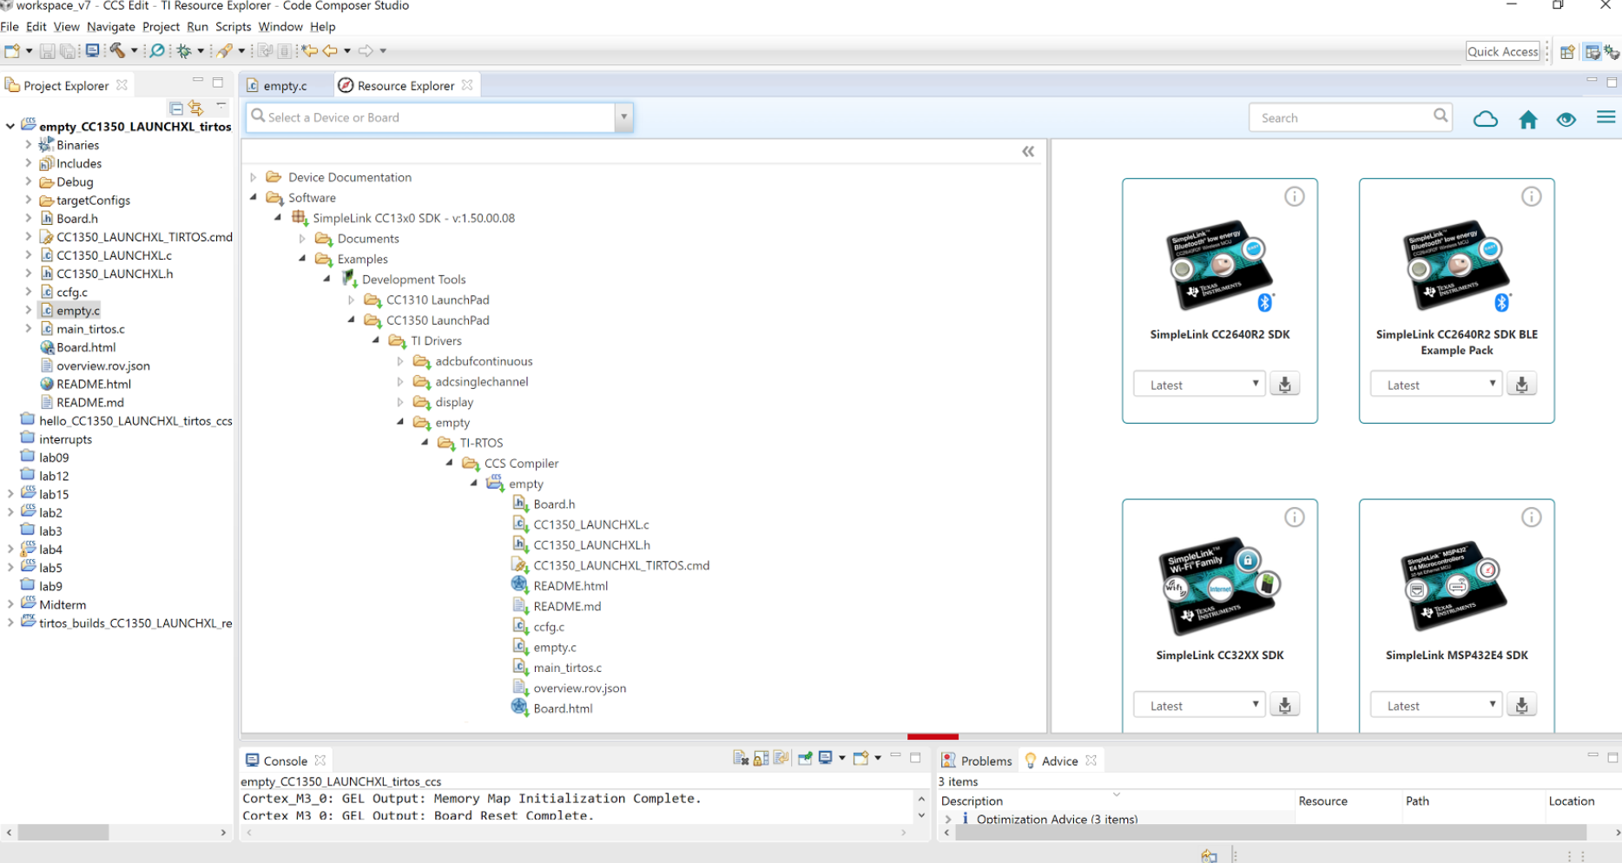

**Figure 1 – Task 1.a Empty Template**

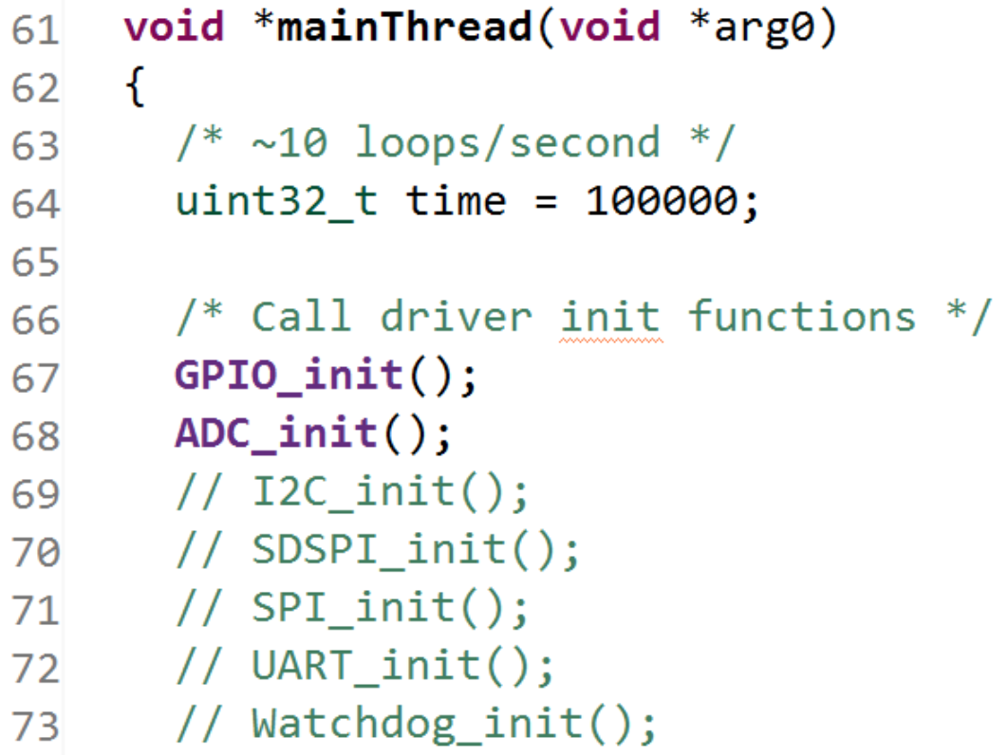

**Figure 2 – Task 1.b mainThread Function**

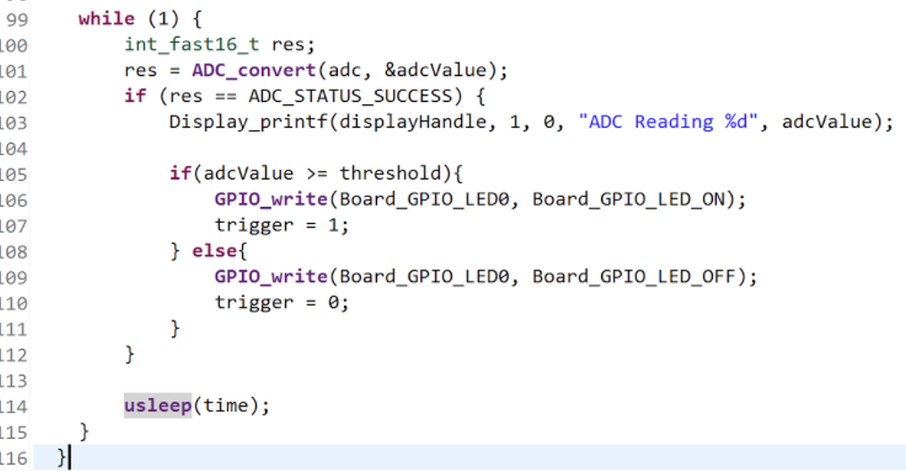

**Figure 3 – Task 1.c ADC Conversion**

# Task 2: Modify the example so LED is ON only if an ADC reading exceeds a threshold

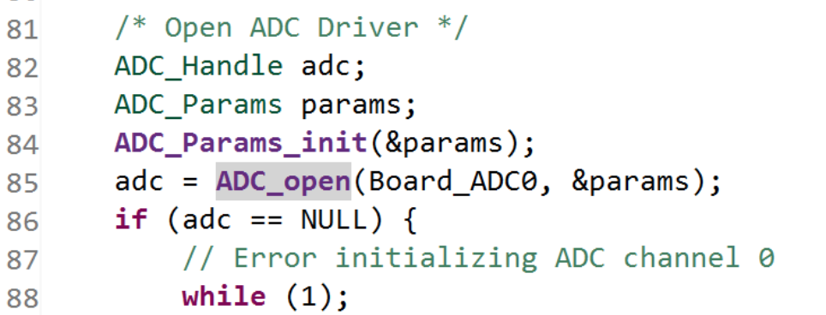

**Figure 4 – Task 2.a ADC Handle**

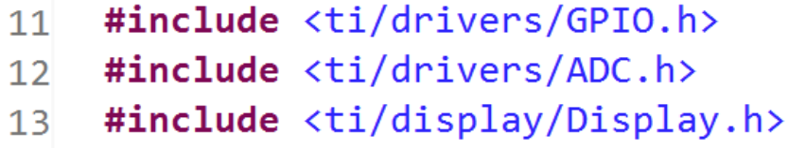

**Figure 5 – Task 2.b GPIO, ADC, Display Includes**

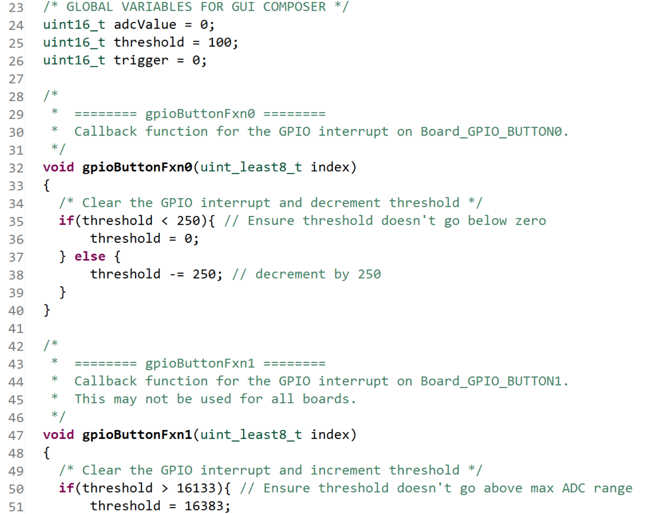

**Figure 6 – Task 2.c Added-in Callback Functions**

# Task 3: Adding a serial UART transmission to report ADC readings

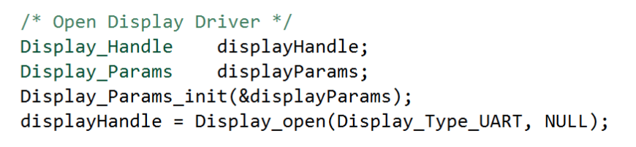

**Figure 7 – Task 3.a Display Driver**

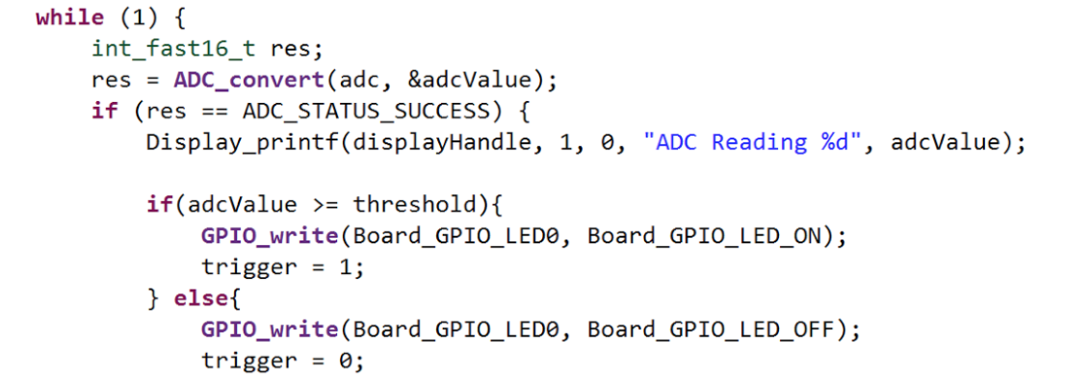

**Figure 8 – Task 3.b ADC Conversion**

# Task 4: Adding GPIO interrupts to our base example

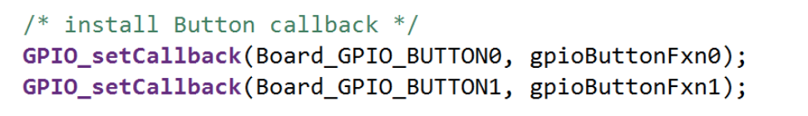

**Figure 9 – Task 4.a Button Callback Functions**

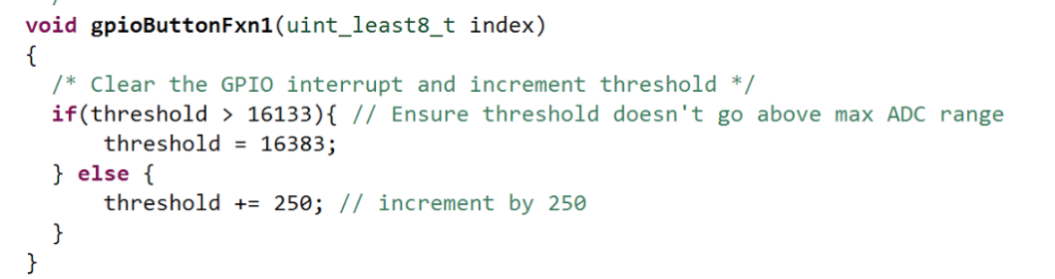

**Figure 10 – Task 4.b Interrupt Threshold Code**